CHAPTER 9 : Conversion Investigation Methods
Mark is a young business student at the University of Georgia, who works part time as a financial adviser at a local credit union. Mark has been married a little over two years. Mark’s wife is currently taking care of their newborn son, while Mark finishes up school. Mark is well liked by all those who know him. In fact, those who know Mark would describe him as outgoing, funny, and very intelligent. At the credit union, Mark’s primary responsibilities are to set up new accounts, make initial loan interviews, and work as a teller. While at work, Mark always appears to be working hard and rarely misses work (even for vacations). Often times, Mark is the first one to volunteer to stay late and look over accounts or help clean up. Over the last four months, Mark’s credit union supervisor has noticed that Mark has been making some interesting purchases. Four months ago, Mark purchased a big-screen television and has frequently invited other coworkers to watch movies at his home. One month ago, Mark bought three new wool suits, which he frequently wears to work. Two months ago, Mark traded in his old Geo Prism for a new Jeep Grand Cherokee (with many expensive features). When asked where he was getting the money for these purchases, Mark humorously responded, “I guess people are right—when you die, you can’t take it all with you. However, it sure was nice they left it with me.” This was an allusion to the fact that a wealthy grand- mother had recently passed away and left Mark (her favorite grandson) a significant inheritance. Also, the supervisor has recently heard some of the new customers complaining that their balances are off by $20, $30, and even $50.
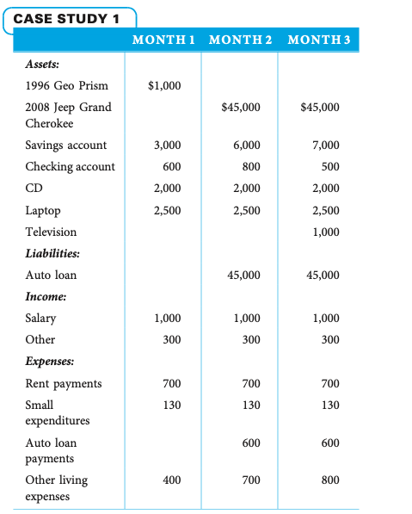

- What fraud symptoms are present in this scenario?
- Is it possible to know from the information above that Mark is committing fraud at the credit union?
- What is one reasonable action the supervisor could do if he or she suspected Mark was committing fraud?
- Assuming that the credit union decides to investigate further, calculate Mark’s net worth and income from other sources.

CASE STUDY 3
Steve (Slick) Willy, 45, just got out of jail. As a reformed citizen on parole, Slick decides to go into business for himself. He starts a collections company to help companies collect debts. The terms of his parole stipulate that he pay restitution payments to the federal government of $400 a month, or 10 percent of his income, whichever is greater. As his parole officer, you notice that after a year out of jail, Slick makes some interesting purchases. First, he buys a new Jaguar, which he drives to parole meetings. Second, he moves into an expensive neighborhood on the north side of town and takes a cruise to Jamaica with his 19-year-old girlfriend. Yet, he has never been late making his $400 monthly payments to the federal government. After obtaining a subpoena for his bank records, you notice that he has only $1,000 in his account. About this time, you receive a call from a man who is making payments to Slick’s collection company. He states that Slick is threatening to break his legs and hurt his family if he doesn’t pay Slick’s company. The man says Slick demands the checks be made out to a woman, not a company. This complaint convinces you to investigate Mr. Willy and his girlfriend. A search of UCC filings in the county shows that Slick’s girlfriend owns three cars costing a total of $90,000, a $250,000 house, and a company called Tak’It From You. You check her bank account and see that more than $50,000 is moving through the account each month. You decide to dig through Slick and his girlfriend’s trash a few times each month. In these searches, you find evidence that supports the following: three car payments totaling $1,000 per month; a $1,500 monthly mortgage payment; a credit card balance of $6,000, with $100 monthly payments; a balance of $12,000 owed to Home Shopping Network, with $500 monthly payments; $400 food payments during the past two weeks; and a $3,500 payment to Jamaican Cruise Lines. After searching the girlfriend’s trash, you talk to her neighbors, friends, and coworkers and determine that she and Slick spend between $1,500 and $2,000 a month on miscellaneous items and trips. One neighbor tells you that Slick just gave his girlfriend a diamond ring that cost $3,000. Slick’s girlfriend works as a waitress at small restaurant and makes only $15,000 a year. (Note: Assume that both Slick and his girlfriend’s net worth last year were zero.)

